Ideation Phase
Brainstorm & Idea Prioritization Template
Date | 01 October 2026
Team ID | [SWTID-2026-8917]
Project Name | Blog Nest – AI-Powered Blogging & Content Management Backend
Maximum Marks | 4 Marks

Brainstorm & Idea Prioritization Template:
Brainstorming gave the team an open space to propose many ideas for a smarter blogging backend, build on each other's suggestions, and then narrow them down to a feasible, high-impact scope for Blog Nest.
Step-1: Team Gathering, Collaboration and Select the Problem Statement
The team met to discuss the pain points that bloggers, editors and administrators face when running a content platform. The problem statement selected for the project was:
“Content creators struggle to manage drafts, categories, tags, comments and approvals in one secure place, and writing every post from scratch is slow. How might we build a secure, role-based backend that manages the full blog lifecycle and uses AI to speed up writing?”
Team Member | Role in session | Focus area
[Member 1] | Facilitator / Backend lead | Authentication, RBAC, API design
[Member 2] | Developer | Blog, category, tag and comment modules
[Member 3] | Developer | Gemini AI integration
[Member 4] | Tester / Documentation | Postman testing, reports
Step-2: Brainstorm, Idea Listing and Grouping
Every member listed ideas freely, then similar ideas were grouped into themes.
Theme | Ideas generated
Security & Access | JWT-based login and protected routes  bcrypt password hashing  Four roles: Admin, Editor, Author, Reader  Rate limiting on login and sensitive routes  Input sanitization against XSS and NoSQL injection
Content Management | CRUD for posts with draft / scheduled / published states  Categories and tags for organising posts  Media metadata and asset paths for posts  Keyword, category and tag search  Public read-only endpoints for readers
Collaboration & Moderation | Reader comments on published posts  Comment states: approved, pending, spam  Editor review queue for pending posts  Admin control over users and roles
AI Assistance | AI blog generation from a topic using Google Gemini  AI summarization of long articles  Prompt templates for consistent blog structure
Future / Stretch | Front-end web or mobile client  Real-time notifications  Analytics dashboard for post performance  Multi-language AI content  Caching of popular posts
Step-3: Idea Prioritization
Ideas were plotted by impact against ease of implementation. Ideas in the top-right were built first; stretch ideas were moved to Future Enhancements.
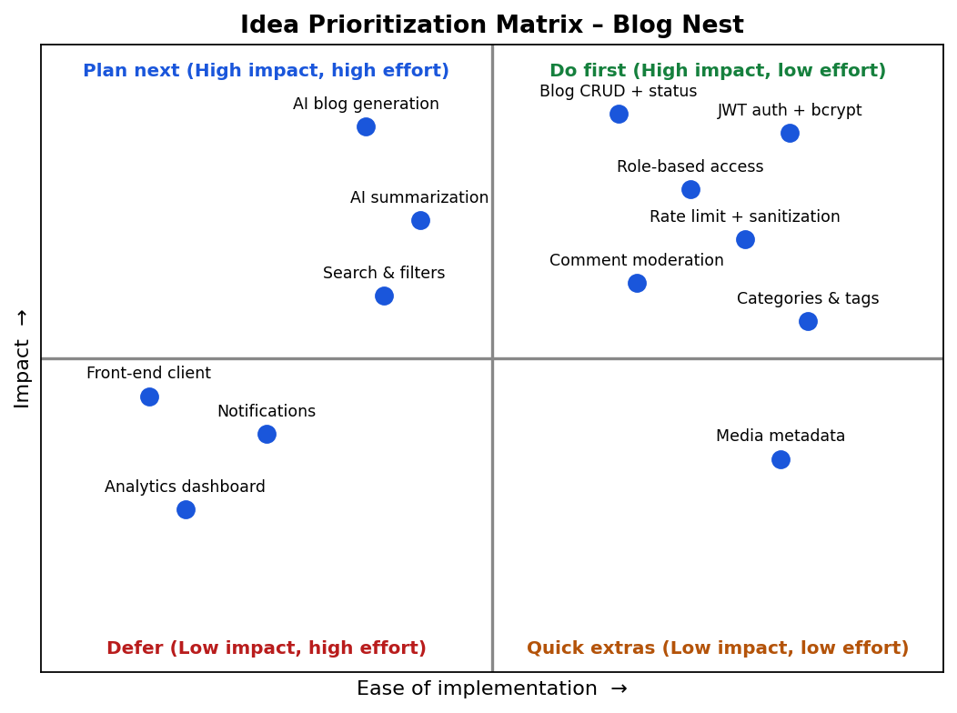
Figure 1: Idea prioritization matrix
Priority | Ideas | Decision
High | JWT auth + bcrypt, role-based access, blog CRUD with status, comment moderation, categories & tags, rate limiting + sanitization | Build in Sprint-1 to Sprint-3 / Sprint-4
High (core differentiator) | AI blog generation, AI summarization, search & filters | Build in Sprint-2 / Sprint-3
Medium | Media metadata handling | Build in Sprint-2
Low / Future | Notifications, analytics dashboard, front-end client, multi-language AI, caching | Documented under Future Enhancements

